**Flavornaut**

**Recipe Sharing Platform**

*Project Report*

*Submitted by*

**Sandra Mohan**

**Reg. No.: AJC23MCA-2056**

*In Partial fulfillment for the Award of the Degree of*

**MASTER OF COMPUTER APPLICATIONS**

**(MCA TWO YEAR)**

**(Accredited by NBA)**

**APJ ABDUL KALAM TECHNOLOGICAL UNIVERSITY**

**AMAL JYOTHI COLLEGE OF ENGINEERING AUTONOMOUS**

**KANJIRAPPALLY**

[Affiliated to APJ Abdul Kalam Technological University, Kerala. Approved by AICTE, Accredited by NAAC. Koovappally, Kanjirappally, Kottayam, Kerala – 686518]

# 2023-2025

## DEPARTMENT OF COMPUTER APPLICATIONS

### AMAL JYOTHI COLLEGE OF ENGINEERING AUTONOMOUS

**KANJIRAPPALLY**



**CERTIFICATE**

This is to certify that the Project report titled “**Flavornaut-Recipe Sharing Platform”** is the bona fide work of **SANDRA MOHAN (Regno: AJC23MCA-2056)** carried out in partial fulfillment of the requirements for the award of the **Degree of Master of Computer Applications** at **Amal Jyothi College of Engineering Autonomous, Kanjirappally,** Affiliated to **APJ Abdul Kalam Technological University.** The project was undertaken during the period from **December 10, 2024,** to **March 27, 2025**.

**Ms. Gloriya Mathew Meera Rose Mathew**

**Internal Guide Coordinator**

**Rev. Fr. Dr. Rubin Thottupurathu Jose External Examiner**

**Head of the Department**

**// CERTIFICATE ON PLAGIARISM CHECK**

**DECLARATION**

I hereby declare that the project report **“Flavornaut-Recipe Sharing Platform”** is a bona fide work done at **Amal Jyothi College of Engineering Autonomous, Kanjirappally**, Affiliated to **APJ Abdul Kalam Technological University**, towards the partial fulfilment of the requirements for the award of the **Master of Computer Applications (MCA)** during the period from **December 10, 2024** to **March 27, 2025**.

**Date: SANDRA MOHAN**

**KANJIRAPPALLY Reg: AJC23MCA-2056**

# ACKNOWLEDGEMENT

First and foremost, I thank God almighty for his eternal love and protection throughout the project. I take this opportunity to express my gratitude to all who helped me in completing this project successfully. It has been said that gratitude is the memory of the heart. I wish to express my sincere gratitude to our Director (Administration) **Rev. Fr. Dr. Roy Abraham Pazhayaparampil** and Principal **Dr. Lillykutty Jacob** for providing good faculty for guidance.

I owe a great depth of gratitude towards our Head of the Department **Rev. Fr. Rubin Thottupurathu Jose** for helping us. I extend my wholehearted thanks to the project coordinator **Ms. Meera Rose Mathew** for her valuable suggestions and for overwhelming concern and guidance from the beginning to the end of the project. I would also express sincere gratitude to my guide **Ms. Gloriya Mathew** for her inspiration and helping hand.

I thank our beloved teachers for their cooperation and suggestions that helped me throughout the project. I express my thanks to all my friends and classmates for their interest, dedication, and encouragement shown towards the project. I convey my hearty thanks to my family for the moral support, suggestions, and encouragement to make this venture a success.

SANDRA MOHAN

# ABSTRACT

The Recipe Sharing Platform is an innovative web application built using Django designed to empower users to create, share, and discover culinary delights. This platform provides an integrated, user-friendly experience for recipe management, meal planning, and ingredient knowledge. It offers additional features such as dietary analysis and providing nutritional insights for enhanced user engagement.

The platform's core functionalities include user authentication, recipe management, categorization, and search. Features such as recipe sharing, meal planning ingredient knowledge, and recipe review further enrich the user experience. Recipe contests, complete with clear guidelines and judging criteria, encourage participation and community interaction. To optimize content and improve user engagement, the platform leverages analytics to understand user behavior. Robust security and scalability are prioritized to ensure a reliable and user-centric experience.

To further enhance the platform, ML-powered features will be implemented:

**Advanced Personalized Recommendations:**

Unlike traditional systems that suggest recipes based solely on user interactions, this platform uses a hybrid approach:

Combines collaborative filtering (user-user and item-item similarity) with content-based filtering (recipe ingredients, nutritional values, tags, etc.). Adapts dynamically to seasonal trends and ingredient availability.

**Basic Recipe Recommendations**

Start with content-based filtering, which matches recipes based on shared tags or ingredients. No advanced algorithms are required. Compute similarity scores between recipes using tags or ingredient lists. Recommend recipes with high similarity scores to the user.

**Recipe Upload Quality Check**

Use predefined rules or basic ML to check for common issues like missing ingredients or unclear instructions. Define rules for checking recipe completeness (e.g., all fields are filled). Optionally, use NLP for simple grammar checks in instructions.

Tools: TextBlob or NLTK for text validation.

**Recipe Image Classification**

Why it's easy: Use pre-trained models to classify recipe images (e.g., "Vegetarian," "Dessert").

Collect images with labels. Use a pre-trained model like MobileNet or ResNet to classify.

Tools: TensorFlow or PyTorch with transfer learning.

**CONTENT**

|  |  |  |  |  |
| --- | --- | --- | --- | --- |
| **SL. NO** | | **TOPIC** | **PAGE NO** | |
| **1** | | **INTRODUCTION** |  | |
| **1.1** | | **PROJECT OVERVIEW** |  | |
| **1.2** | | **PROJECT SPECIFICATION** |  | |
| **2** | | **SYSTEM STUDY** |  | |
| **2.1** | | **INTRODUCTION** |  | |
| **2.2** | | **EXISTING SYSTEM** |  | |
| **2.2.1** | | **DRAWBACKS OF EXISTING SYSTEM** |  | |
| **2.3** | | **PROPOSED SYSTEM** |  | |
| **2.3.1** | | **ADVANTAGES OF PROPOSED SYSTEM** |  | |
| **3** | | **REQUIREMENT ANALYSIS** |  | |
| **3.1** | | **FEASIBILITY STUDY** |  | |
| **3.1.1** | | **ECONOMICAL FEASIBILITY** |  | |
| **3.1.2** | | **TECHNICAL FEASIBILITY** |  | |
| **3.1.3** | | **BEHAVIORAL FEASIBILITY** |  | |
| **3.1.4** | | **FEASIBILITY STUDY QUESTIONNAIRE** |  | |
| **3.1.5** | | **GEOTAGGED PHOTOGRAPH** |  | |
| **3.2** | | **SYSTEM SPECIFICATION** |  | |
| **3.2.1** | | **HARDWARE SPECIFICATION** |  | |
| **3.2.2** | | **SOFTWARE SPECIFICATION** |  | |
| **3.3** | | **SOFTWARE DESCRIPTION** |  | |
| **3.3.1** | | **PHP** |  | |
| **3.3.2** | | **MYSQL** |  | |
| **4** | | **SYSTEM DESIGN** |  | |
| **4.1** | | **INTRODUCTION** |  | |
| **4.2** | | **UML DIAGRAM** |  | |
| **4.2.1** | | **USE CASE DIAGRAM** |  | |
| **4.2.2** | | **SEQUENCE DIAGRAM** |  | |
| **4.2.3** | | **STATE CHART DIAGRAM** |  | |
| **4.2.4** | | **ACTIVITY DIAGRAM** |  | |
| **4.2.5** | | **CLASS DIAGRAM** |  | |
| **4.2.6** | | **OBJECT DIAGRAM** |  | |
| **4.2.7** | | **COMPONENT DIAGRAM** |  | |
| **4.2.8** | | **DEPLOYMENT DIAGRAM** |  | |
| **4.2.9** | | **COLLABORATION DIAGRAM** |  | |
| **4.3** | | **USER INTERFACE DESIGN USING FIGMA** |  | |
| **4.4** | | **DATABASE DESIGN** |  | |
| **5** | | **SYSTEM TESTING** |  | |
| **5.1** | | **INTRODUCTION** |  | |
| **5.2** | | **TEST PLAN** |  | |
| **5.2.1** | **UNIT TESTING** | |  |
| **5.2.2** | **INTEGRATION TESTING** | |  |
| **5.2.3** | **VALIDATION TESTING** | |  |
| **5.2.4** | **USER ACCEPTANCE TESTING** | |  |
| **5.2.5** | **AUTOMATION TESTING** | |  |
| **5.2.6** | **SELENIUM TESTING** | |  |
| **6** | **IMPLEMENTATION** | |  |
| **6.1** | **INTRODUCTION** | |  |
| **6.2** | **IMPLEMENTATION PROCEDURE** | |  |
| **6.2.1** | **USER TRAINING** | |  |
| **6.2.2** | **TRAINING ON APPLICATION SOFTWARE** | |  |
| **6.2.3** | **SYSTEM MAINTENANCE** | |  |
| **6.2.4** | **HOSTING** | |  |
| **7** | **CONCLUSION & FUTURE SCOPE** | |  |
| **7.1** | **CONCLUSION** | |  |
| **7.2** | **FUTURE SCOPE** | |  |
| **8** | **BIBLIOGRAPHY** | |  |
| **9** | **APPENDIX** | |  |
| **9.1** | **SAMPLE CODE** | |  |
| **9.2** | **SCREEN SHOTS** | |  |
| **9.3** | **GIT LOG** | |  |
| **9.4** | **CERTIFICATES** | |  |

## List of Abbreviations

## • UML - Unified Modelling Language

## • ORM - Object-Relational Mapping

## • MVT - Model-View-Template

## • MVC - Model-View-Controller

## • RDBMS - Relational Database Management System

## • 1NF - First Normal Form

## • 2NF - Second Normal Form

## • 3NF - Third Normal Form

## • IDE - Integrated Development Environment

## • HTML - HyperText Markup Language

## • JS - JavaScript

## • CSS - Cascading Style Sheets

## • AJAX - Asynchronous JavaScript and XML

## • JSON - JavaScript Object Notation

## • API - Application Programming Interface

## • UI - User Interface

## • PK - Primary Key

## • FK - Foreign Key

## • SQL - Structured Query Language

## • CRUD - Create, Read, Update, Delete

# CHAPTER 1

# INTRODUCTION

### PROJECT OVERVIEW

The “Recipe Sharing Platform” is an innovative online community where users can discover, share, and save recipes, catering to both casual cooks and food enthusiasts. Designed to enhance user interaction, recipe management, and community engagement, the platform offers a personalized and immersive culinary experience. Users can create and manage profiles, allowing for a tailored experience as they navigate the platform. The core feature is recipe management, enabling users to create, edit, and delete recipes, complete with ingredients, instructions, and images. An extensive library of recipes is available for browsing, with tools to categorize and tag recipes, making it easy to find and organize dishes. Community engagement is fostered through a rating and review system, encouraging users to share feedback and interact with others. The platform’s powerful search and discovery features allow users to find recipes by name, ingredient, category, tags, and ratings, ensuring quick access to preferred dishes. Advanced functionalities include ingredient substitution suggestions, meal-planning tools, and the ability to share recipes via social media or email. Nutritional information is provided for each recipe, and users can save favorites and contribute cooking tips, enriching the collaborative environment. Unique features like storytelling allow users to share the personal stories behind their recipes while pairing suggestions help create well-rounded meals. The platform also offers an ingredient knowledge base and advanced dietary filtering. To add fun and engagement, the platform hosts recipe competitions with clear guidelines, showcasing winners on the homepage and offering high-rated recipes for sale. Overall, the Recipe Sharing Platform is a vibrant community that blends practical features with social interaction, making it an ideal destination for culinary exploration.

* 1. **PROJECT SPECIFICATION**

### Administrators

* **Manage Users:** Manage user accounts, including registration approvals, account suspensions, and handling user roles (e.g., promoting users to Recipe Managers).
* **Manage Events:** Admins set up and manage recipe contests, including creating guidelines, selecting judges, and announcing winners.
* **Manage Recipes:** Admins are responsible for creating, editing, viewing, and deleting recipes.
* **Manage Ingredients:** They provide in-depth ingredient knowledge, ensuring that substitution suggestions are accurate and useful.
* **Manage Categories:** Admins can create new categories like "Vegetarian," "Non-Vegetarian," "Desserts," "Appetizers," etc.
* **Manage Sub-Categories:** Admins can create sub-categories under specific main categories, such as "Pickles" under "Vegetarian" or "Snacks" under "Non-Vegetarian."

### Users

* **Authentication:** Users can sign up, log in, and manage their profiles.
* **Recipe Management:** Users can create, edit, categorize, and delete their own recipes.
* **Search & Discovery:** Users can search for recipes using various filters, including dietary needs and ingredient substitutions.
* **Meal Planning:** Users can plan meals by selecting recipes.

# CHAPTER 2

# SYSTEM STUDY

* 1. **INTRODUCTION**

The “Recipe Sharing Platform” is an online community where users can discover, share, and save recipes, catering to both casual cooks and food enthusiasts. It offers personalized profiles, allowing users to create, edit, and manage recipes complete with ingredients, instructions, and images. An extensive recipe library enables easy search and organization by category, tags, or ingredients.

Users can rate and review recipes, share tips, and explore dishes using dietary filters and nutritional information. Unique features include ingredient substitution suggestions, meal-planning tools, and recipe storytelling. The platform also hosts recipe competitions, showcasing winners and high-rated recipes for sale, creating a vibrant and interactive culinary community.

* 1. **EXISTING SYSTEM**

The existing system of recipe-sharing platforms generally offers basic features like recipe discovery, user submissions, and simple search functions. However, these platforms often fall short in terms of depth and personalization. Search capabilities are limited to broad categories or keywords, making it difficult for users to find recipes tailored to specific dietary needs or preferences. Personalization is minimal, lacking tailored recommendations based on user behavior. Social engagement features are also underdeveloped, with few opportunities for users to build connections or participate in community activities. Additionally, comprehensive ingredient knowledge, substitution options, and detailed nutritional information are often missing or inconsistent. Overall, while functional, these platforms do not fully meet users’ expectations for a rich, interactive, and personalized culinary experience.

* 1. **DRAWBACKS OF EXISTING SYSTEM**
* Limited search and discovery: Finding specific recipes or exploring new cuisines can be challenging due to poor search functionality or limited categorization.
* Inconsistent recipe quality: Variations in recipe format, clarity, and accuracy can lead to frustration for users.
* Lack of personalization: Most systems fail to tailor recommendations based on individual preferences, dietary restrictions, or cooking experience.
* Insufficient nutritional information: Many recipes lack detailed nutritional data, making it difficult for users to make informed dietary choices.
* Paid content or advertisements: Some platforms rely on subscription fees or intrusive ads, which can diminish the user experience.

**2.4 PROPOSED SYSTEM**

The proposed recipe-sharing platform goes beyond conventional cooking sites by focusing on a holistic, community-driven culinary experience. Every element has been thoughtfully designed to engage users in ways that blend functionality, inspiration, and social interaction, making it a one-stop destination for food lovers, from home cooks to culinary enthusiasts. This platform empowers users not only to discover and save recipes but also to develop a sense of ownership and pride in their cooking journeys. With features such as user profiles, followers, and recipe collections, users can showcase their culinary accomplishments, build personalized recipe libraries, and follow their favorite creators for ongoing inspiration.

A highlight of the platform is its smart ingredient and dietary management capabilities, catering to modern dietary needs and preferences with unmatched ease. Ingredient substitution suggestions help users adapt recipes to their taste or dietary restrictions, whether by swapping dairy with plant-based alternatives or finding gluten-free ingredient options. With meal planning tools, users can organize their weekly menus, ensuring balanced meals and minimizing food waste. The platform’s detailed nutritional analysis, readily available for each recipe, empowers users to make health-conscious decisions in line with their dietary goals, tracking everything from calories and macronutrients to vitamin intake.

Beyond its core features, the platform encourages community engagement and social sharing in creative and dynamic ways. Through storytelling, users can add personal reflections, family anecdotes, or cultural context to recipes, transforming each dish into a shared experience that extends beyond the kitchen. This feature builds deeper connections, creating a sense of community and encouraging conversations around food traditions, memories, and regional flavors. An advanced rating and review system adds an extra layer of trust, allowing users to share detailed feedback on recipes, help others discover top-rated dishes, or avoid common pitfalls in complex recipes.

Search and discovery tools on the platform are enhanced by a powerful tagging system, which enables users to filter recipes not only by type or cuisine but also by unique attributes like cooking methods, preparation times, or seasonal ingredients. Users can explore everything from quick weeknight dinners to elaborate holiday feasts with ease, guided by smart search filters and visually appealing recipe thumbnails. Multimedia support further enriches the platform, with high-quality images and video tutorials for each recipe step, providing users with a visually engaging cooking guide that boosts confidence and eases the learning curve for challenging dishes.

In fostering a collaborative spirit, the platform regularly hosts recipe contests, seasonal challenges, and themed cooking events, inviting users to showcase their skills and explore new techniques. This gamified approach keeps users motivated, bringing an element of fun and excitement to cooking while also offering the opportunity to earn recognition and rewards. Furthermore, administrators and recipe managers actively curate and promote high-quality content, highlighting exceptional recipes and elevating standout creators, ensuring that users are constantly exposed to fresh ideas and trending flavors.

With its seamless blend of social features, practical tools, and a vibrant community focus, this platform doesn’t just cater to everyday cooking needs—it aims to inspire culinary exploration, encourage knowledge sharing, and celebrate the universal love of food. The platform aspires to become a culinary hub, where users can learn, teach, and connect with others, creating a dynamic ecosystem that transforms cooking from a solitary task into a shared, interactive, and enriching experience.

**2.4 ADVANTAGES OF PROPOSED SYSTEM**

* **Comprehensive Recipe Management:** Users can easily create, manage, and categorize their recipes, providing a well-organized and personalized collection. Advanced search functionalities and filters ensure users can quickly find recipes that meet their specific needs, such as dietary restrictions or ingredient availability.
* **Ingredient Substitution Suggestions:** The platform offers intelligent substitution options, allowing users to adapt recipes based on available ingredients or dietary preferences. This feature adds flexibility and usability to the recipe collection.
* **Meal Planning Tools**: Users can plan their meals efficiently by selecting recipes and generating shopping lists, which simplifies meal preparation and grocery shopping.
* **Detailed Nutritional Information**: Users have access to comprehensive nutritional data for recipes, enabling them to make informed dietary choices and track their nutritional intake more effectively.
* **Recipe Contests**: The introduction of recipe contests with clear guidelines motivates users to showcase their culinary skills and creativity. This feature not only engages users but also adds a fun and competitive element to the platform.

# CHAPTER 3

# REQUIREMENT ANALYSIS

## FEASIBILITY STUDY

A feasibility study is a comprehensive evaluation of a proposed project to determine its practicality and potential for success. This process begins with analyzing the technical aspects of the project to ensure that the necessary technology, skills, and infrastructure are available or can be acquired. It involves evaluating whether the proposed system can be integrated with existing technologies and if the team possesses the requisite technical expertise. The study also considers operational aspects such as system usability and integration with existing workflows, as well as market demand and competitive landscape. By identifying potential risks and challenges early, the feasibility study helps stakeholders make informed decisions, optimize resource allocation, and reduce the likelihood of costly errors and project failures. This comprehensive analysis provides a solid foundation for successful project planning and execution.

### Economical Feasibility

Conducting an economic feasibility analysis is essential for assessing the financial viability and investment requirements of the recipe-sharing platform. This analysis involves a detailed examination of the costs associated with developing the platform, including technology infrastructure, content management, and operational expenses. It also evaluates potential revenue streams, such as subscription fees The platform’s alignment with growing consumer interest in culinary exploration and personalized food experiences further enhances its economic feasibility. Core features like user profiles, recipe management, and community interactions can be built with web development frameworks, databases, and APIs. Advanced functionalities such as ingredient substitution, meal planning, and dietary filtering are achievable with search engines and nutritional databases. Social sharing, security, and scalability can be managed using social media APIs, cloud infrastructure, and secure authentication protocols. Overall, the platform can be effectively built, scaled, and maintained with current technology and best practices.

### Technical Feasibility

The technical feasibility study for the Recipe Sharing Platform demonstrates a strong potential for successful implementation due to several key factors. The development team possesses the expertise and resources needed to leverage modern web technologies and best practices. Advanced features like robust search functionalities, ingredient substitution suggestions, and personalized recommendations are within reach, thanks to the platform's use of Django and its extensive libraries. Scalability is a critical aspect of the platform’s feasibility. Efficient coding practices and a solid infrastructure ensure that the system can handle increasing user traffic and an expanding recipe database. Technical assessments confirm that the platform adheres to industry standards, which guarantees it will meet performance requirements and remain adaptable as the platform grows. Overall, the study verifies that the project is not only technically viable but also well-positioned to deliver a comprehensive and user-friendly experience.

### Behavioral Feasibility

Behavioral feasibility is a crucial aspect of evaluating the recipe-sharing platform, focusing on user and stakeholder acceptance and engagement.

**User Acceptance**: For the platform to succeed, it must enhance the culinary experience by providing valuable features such as meal planning tools, and nutritional information. The success of the project hinges on users' willingness to adopt and actively engage with the platform for discovering, sharing, and managing recipes.

**Recipe Contributor Engagement**: The platform relies on recipe contributors to upload and manage their recipes. Their readiness to embrace the digital environment, share detailed recipes, and interact with the community is essential. Behavioral feasibility assesses their enthusiasm and readiness to engage with the platform’s features.

**Administrative Adaptation**: Administrators are crucial for the effective operation of the platform, handling tasks such as user management, content moderation, and system maintenance. Their acceptance of the platform’s functionalities and their ability to manage these responsibilities efficiently are vital for smooth operation.

* + 1. **Feasibility Study Questionnaire**

**1. Project Overview?**

The primary objective of the project is to develop a comprehensive recipe-sharing platform that enables users to create, share, and discover a wide range of culinary delights. The platform aims to enhance user experience through advanced features like ingredient substitution suggestions, meal planning tools, and detailed nutritional information. It seeks to foster a vibrant community by encouraging recipe sharing, storytelling, and user-generated content. By incorporating social interaction features, engaging contests, and a premium content system, the platform aims to build a connected and dynamic online community centered around food, inspiration, and shared culinary experiences.

**2.** **To What Extent the System Is Proposed For?**

The “Recipe Sharing Platform” is proposed to offer a comprehensive and user-centric recipe-sharing experience. It includes core functionalities such as user authentication, recipe management, and advanced search features. The platform will provide additional tools like ingredient substitution suggestions, meal planning, and nutritional information. It aims to foster community engagement through recipe sharing, storytelling, and user-generated content. Social interaction features and recipe contests will further enhance user involvement. The system is designed with a focus on robust security and scalability to support a growing user base and ensure a reliable platform.

**3. Specify the Viewers/Public who are to be involved in the System.**

General Visitors, Regular Users, Recipe Managers

**4. List the Modules included in your System.**

Admin, Guest Users

**5. Identify the users in your project.**

Guest Users, Chefs

**6. Who owns the system?**

Administrator

**7. System is related to which firm/industry/organization?**

Food and Culinary

**8. Details of the person that you have contacted for data collection.**

Nakul B Narayanan (Kitchen alchemist)

1. **Questionnaire to collect details about the project?**
2. **What are the primary types of recipes featured on your website (e.g., traditional, contemporary, regional)?**

Our website features a wide range of recipes, including traditional, contemporary, and regional dishes. We cater to diverse tastes, offering everything from classic comfort foods to modern, health-conscious meals.

1. **Are there any unique features on your website that set it apart from other recipe platforms?**

One of our standout features is the "Ingredient Swap" tool, which suggests alternatives for ingredients users may not have on hand or want to avoid. We also offer interactive cooking classes and live Q&A sessions with professional chefs.

1. **What tools or features do you provide for users to interact with the content (e.g., commenting, rating, sharing)?**

User can interact with our content by commenting on recipes, rating them, and sharing their own tips or modifications. They can also share recipes with friends and family via email or social media.

1. **Can users create and save personal recipe collections?**

Yes, users can create and save personal recipe collections. They can categorize these collections based on themes like "Holiday Favourites," "Quick Weeknight Dinners," or "Vegan Options."

1. **Do you have a feature for users to share recipes on social media?**

We have built-in features that allow users to easily share their favourite recipes on social media platforms like Facebook, and Instagram.

1. **How do you handle negative feedback or reviews on recipes?**

We value all feedback, including negative reviews, as it helps us improve our content. Our moderation team reviews negative comments to ensure they are constructive, and we often respond with tips or suggestions for better results.

1. **What’s the most recent feature you’ve added to your platform, and what was the motivation behind it?**

The most recent feature we've added is a "Meal Planner" tool that allows users to plan their meals for the week, complete with a shopping list. This was introduced in response to user feedback requesting more tools for meal preparation and organization**.**

1. **Have you partnered with any influencers or chefs to create exclusive content?**

We have partnered with several renowned chefs and food influencers to create exclusive content. These collaborations include video tutorials, special recipe collections, and live cooking demonstrations**.**

1. **How do you ensure that your website is accessible and easy to use for all users?**

We prioritize accessibility by ensuring our website is navigable with screen readers, providing text alternatives for images, and using a clear, easy-to-read font. We also offer step-by-step guides with video and audio instructions for those who prefer multimedia content.

1. **Do you offer personalized recipe recommendations? If so, how do they work?**

Yes, we offer personalized recipe recommendations based on users' preferences, past activity, and dietary restrictions. The more a user interacts with our platform, the more tailored the recommendations become.

**3.1.5 Geotagged Photograph**

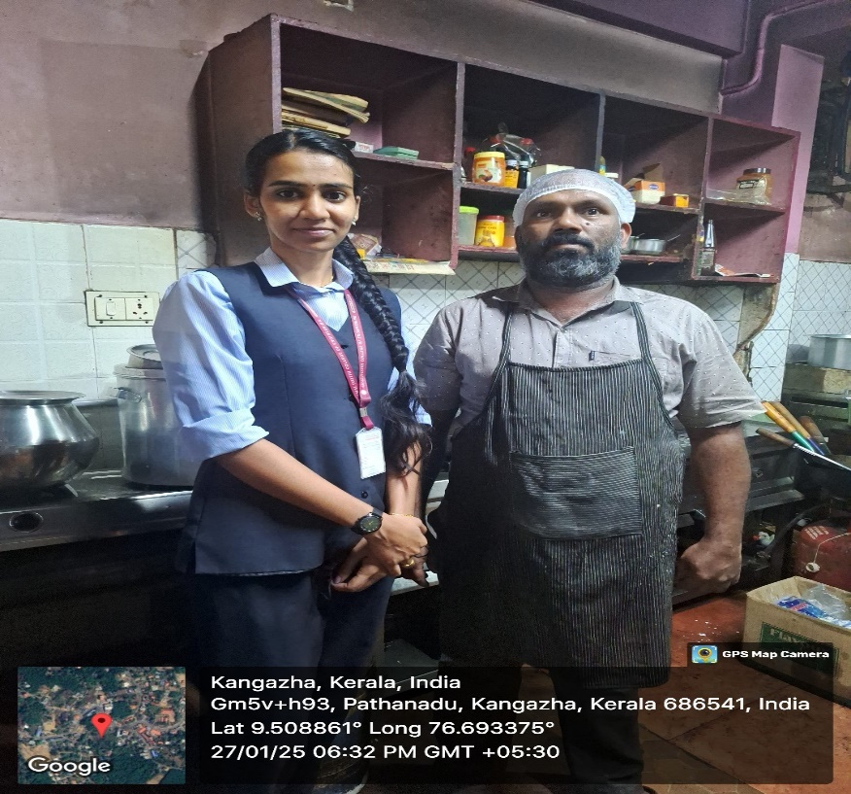

## SYSTEM SPECIFICATION

### Hardware Specification

Processor - Intel core i3

RAM - 8GB

Hard disk - 238GB

### Software Specification

Front End - HTML5, Bootstrap, KCSS

Back End -

Database -

Client on PC - Windows 7 and above.

Technologies used - JS, HTML5, AJAX, J Query, PHP, CSS, List APIs, List ML Functionalities

## SOFTWARE DESCRIPTION

### Eg.PHP

### Eg. MySQL

# CHAPTER 4

# SYSTEM DESIGN

* 1. **INTRODUCTION**

## UML DIAGRAM

## USE CASE DIAGRAM

Explanation, Diagram

## 4.2.2 SEQUENCE DIAGRAM

Explanation, Diagram

## 4.2.3 State Chart Diagram

Explanation, Diagram

## 4.2.4Activity Diagram

Explanation, Diagram

## 4.2.5Class Diagram

Explanation, Diagram

## 4.2.6 Object Diagram

Explanation, Diagram

## 4.2.7Component Diagram

Explanation, Diagram

**4.2.8 Deployment Diagram**

Explanation, Diagram

**4.2.9 Collaboration Diagram**

Explanation, Diagram

## 4.3 USER INTERFACE DESIGN USING FIGMA

**Form Name: abcc**

Screenshot

**Form Name: abcc**

Screenshot

All Forms of Main Project (minimum 8)

## DATABASE DESIGN

## Explanation

### 4.4.1 Relational Database Management System (RDBMS)

Explanation

### 4.4.2 Normalization

### Explanation with example

### 4.4.3 Sanitization

**4.4.4 Indexing**

### 4.5 TABLE DESIGN

**1.Tbl_users_login**

Eg.Primary key: **loginid**

Eg.Foreign key: **loginid** references table **Tbl_users_login**

|  |  |  |  |  |
| --- | --- | --- | --- | --- |
| **No:** | **Field name** | **Datatype (Size)** | **Key Constraints** | **Description of the field** |
|  |  |  |  |  |
|  |  |  |  |  |
|  |  |  |  |  |
|  |  |  |  |  |

**##All tables**

# CHAPTER 5

# SYSTEM TESTING

* 1. **INTRODUCTION**

Explanation

## TEST PLAN

Explanation

### Unit Testing

explanation

### Integration Testing

Explanation

### Validation Testing or System Testing

Explanation

### Output Testing or User Acceptance Testing

explanation.

* + 1. **Automation Testing**

explanation.

* + 1. **Selenium Testing**

explanation.

**Example:**

**Test Case 1**

**Code**

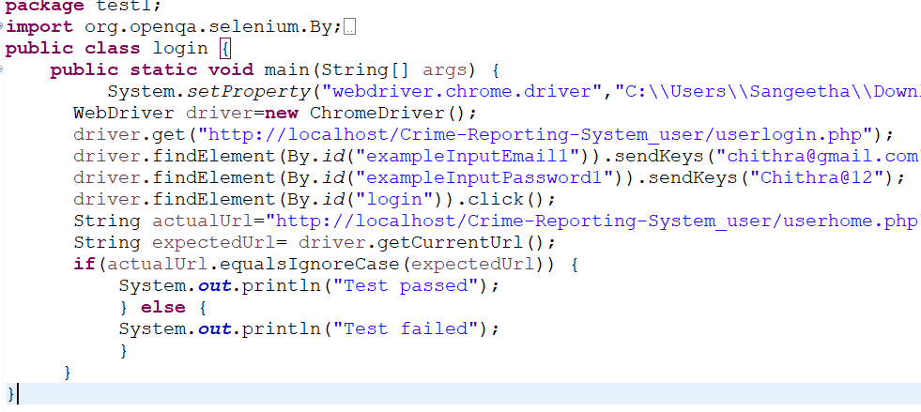

**Eg.Screenshot**

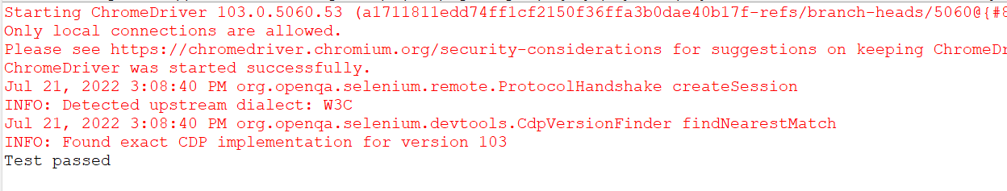

**Eg.Test Report**

|  |  |  |  |  |  |
| --- | --- | --- | --- | --- | --- |
| **Test Case 1** | | | | | |
| **Project Name:** | | | | | |
| **Login Test Case** | | | | | |
| **Test Case ID: Test_1** | | | **Test Designed By:** | | |
| **Test Priority(Low/Medium/High):** | | | **Test Designed Date:** | | |
| **Module Name**: | | | **Test Executed By :** | | |
| **Test Title :** | | | **Test Execution Date:** | | |
| **Description:** | | |  | | |
| **Pre-Condition :**User has valid username and password | | | | | |
| **Step** | **Test Step** | **Test Data** | **Expected Result** | **Actual Result** | **Status(Pass/**  **Fai l)** |
| 1 |  |  |  |  |  |
| 2 |  |  |  |  |  |
| 3 |  |  |
| 4 |  |  |
| 5 |  |  |  |  |  |
|  |  |  |  |  |  |
| 6 |  |  |
| 7 |  |  |  |  |  |
|  |  |  |  |  |
| **Post-Condition:** | | | | | |

**Test Case 2:**

**Code**

**Screenshot**

**Test report**

**Minimum 6 test cases of main project (1 Registration and login 5 different functionalities of main project, Can include Pass/Fail status)**

# CHAPTER 6

# IMPLEMENTATION

## INTRODUCTION

Explanation

## IMPLEMENTATION PROCEDURES

Explanation

### User Training

Explanation

### Training on the Application Software

Explanation

### System Maintenance

Explanation

* + 1. **Hosting**

Explanation

**Eg.000Webhost**

Explanation

**Procedure for hosting a website on 000Webhost:**

Step 1: explanation

Step 2: explanation

Step 3: explanation

.

.

**Hosted Website:**

**Hosted Link:** [**https://abc.000webhostapp.com**](https://abc.000webhostapp.com)

**Hosted Link QR Code**

**Screenshot**

# CHAPTER 7

# CONCLUSION AND FUTURE SCOPE

## CONCLUSION

## 

.

* 1. **FUTURE SCOPE**

.

# CHAPTER 8

# BIBLIOGRAPHY

### REFERENCES

* + - ..//books
    - ..
    - ..
    - ..
    - ...

### WEBSITES

* + - [..](http://www.w3schools.com/)
    - [..](http://www.jquery.com/)
    - [..](http://homepages.dcc.ufmg.br/%7Erodolfo/es-1-03/IEEE-Std-830-1998.pdf)
    - [..](http://www.agilemodeling.com/artifacts/useCaseDiagram.html)

# CHAPTER 9

# APPENDIX

## Sample Code

Main functionalities

## Screen Shots

## All screenshots

## 9.3 Certificates

## (Minimum 5)

Attach Plagiarism Report